**-Task2 Artififcal intelligence (AI):**

Step by step :

1. install parallel

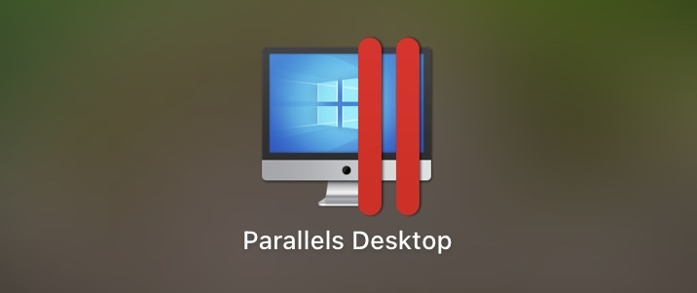

1. and install ubuntu 20.04.2 ARM64

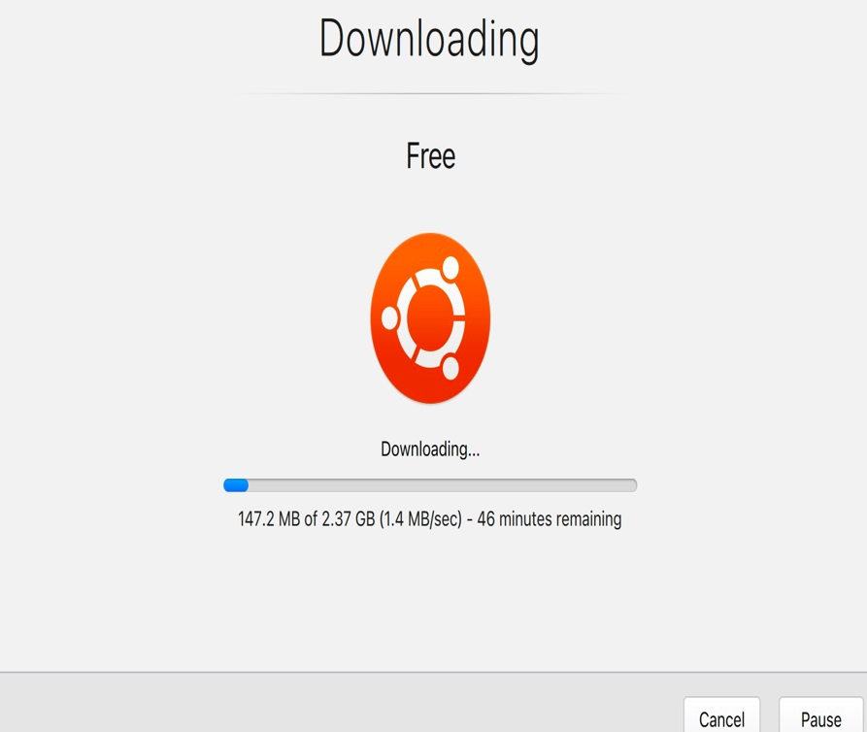

1. Commands to download ROS
2. install ROS
3. commands to arm package in ROS

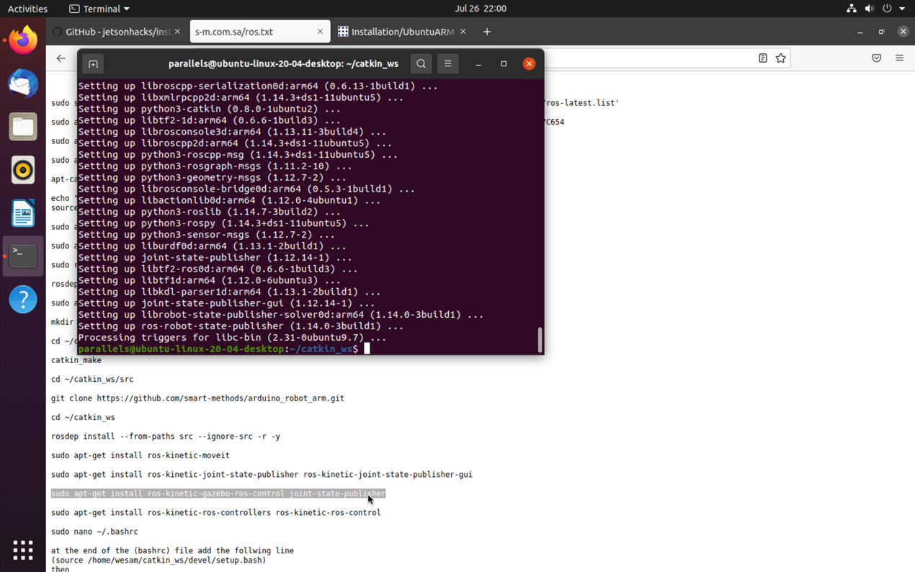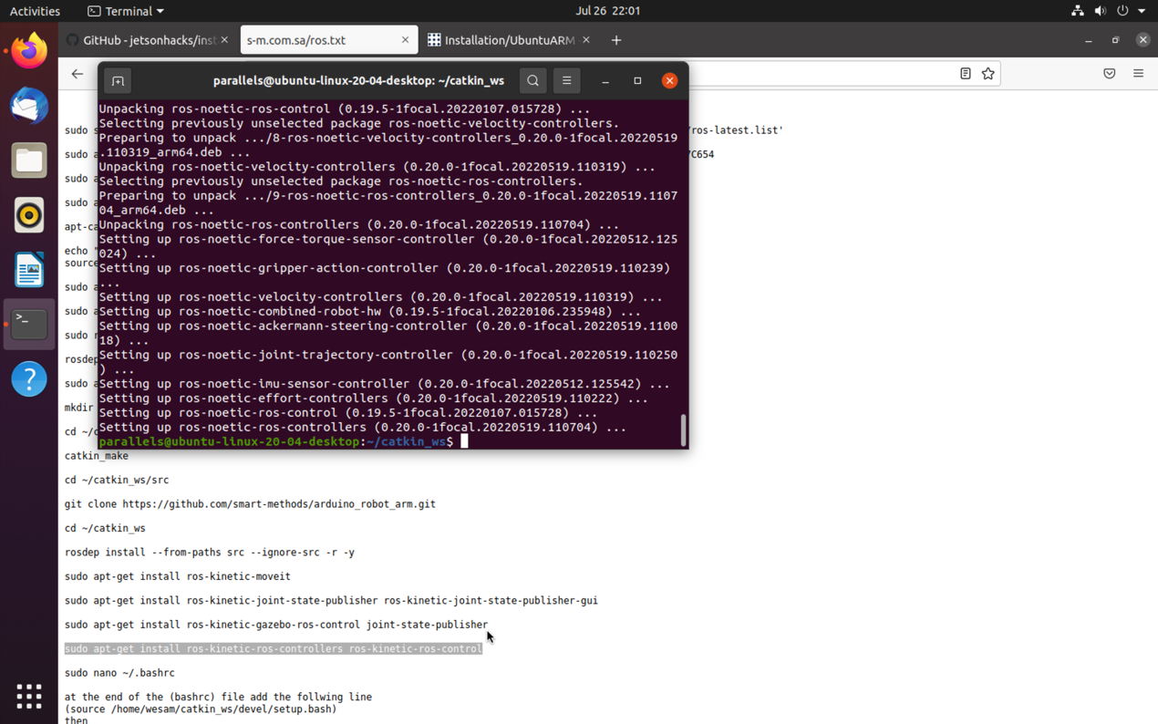

1. install arm package

